Documentation

IP Lab Project

Topic : Tutor Management

By,
E.Anurudhri (120071601012)
A.AfraBanu(120071601007)
B.Tech Final yr cse-A

Purpose
Purpose of eTuition is to make learning easy. Every detail about the tutors are given in the website which makes the users to find everything easily. It also gives you videos of the classes of a particular staff and subject which makes the user understand which staff will be apt for their children. And since the experienced staffs teach their children at home without much difficulty this website will definitely be a very useful one.

Existing System

1. Craigslist (www.craigslist.org):

On Craigslist you can create an ad to market yourself as a tutor. Ads are easy to create and involve creating a title and a description of the educational services you offer. Making the title pertinent to your specialty subjects will give you a better chance of showing up for relevant searches. After creating a Craigslist account, you’ll need to click on the create posting link, and then create your ad under the lessons & tutoring category. Because ads are shown based on the date posted, in order to remain visible, you should periodically delete and re-post your listing.

2. Tutor.com (www.tutor.com):

To become a tutor for Tutor.com, you will need to go through the application process,which begins at http://www.tutor.com/apply/application-process. There are no fees involved in applying, but be prepared to wait up to three weeks to get through the screening process. According to their site, the ability to tutor multiple subjects will give you a better chance of being accepted.

3. TutorVista (www.tutorvista.com):

Applying to TutorVista is the same as applying to any standard job. They require that you submit a resume and cover letter explaining your interests and qualifications for the position. For more information and to search for available openings, visit:http://www.tutorvista.com/teaching-jobs. While this could lead to a semi-permanent position, it is most likely going to be difficult to be accepted and you will not see any money until completing the hiring process.

Project Scope and Complexity

The purpose of this proposed software is to help the students to find their perfect tutor and to make them come up in their educational career. This helps the students to find their tutor in their own location with the help of the resume of the staff they like and to have a conversation either to select them or not. this also enables those to continue teaching by uploading their resumes and registering themselves in our website. The purpose of this proposed Open Source software is to enable the creation of rich multimedia presentation that combines video frame with a slide frame and a table of contents that goes over the major portions of the presentation. The deliverables of the software should be a presentation file with a hosting HTML page as a single compressed folder. This presentation can then be published in the Internet. This project has a lot of scope for future development. Features like ability to capture videos for making presentation, templates for presentation, video transition effects and many more such functionalities can be implemented in the later versions of the software.

Project Functions

unique features

- enables staff to upload their resume
- allows students to select staffs in their location.
- staff can send messages to the staffs they like.

Advantages:

- Estimates(i.e. budget, schedule etc .) become more relistic as work progresses, because important issues discoved earlier.
- It is more able to cope with the changes that are software development generally entails.
Software engineers can get their hands in and start woring on the core of a project earlier

The following diagram shows how a spiral model acts like:

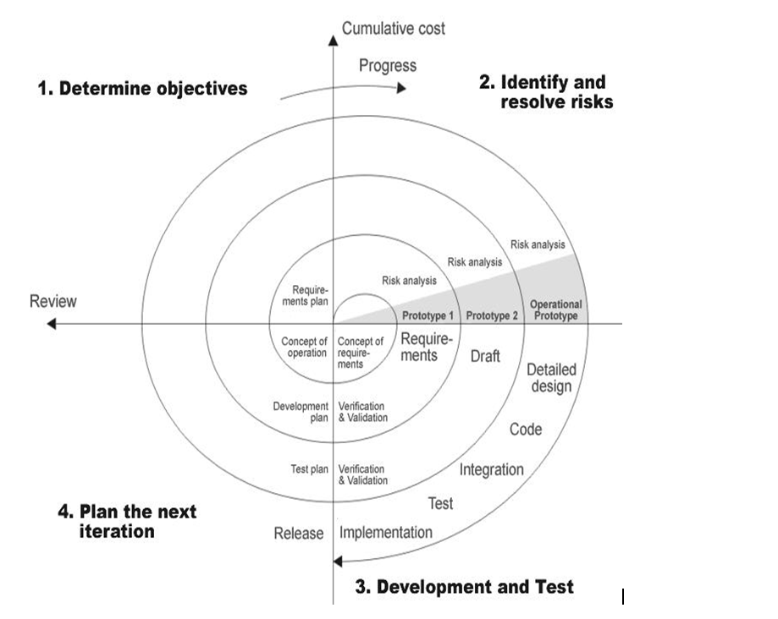

DFD (Context level Diagram):

Student
ADMINISTRATOR
Staff
Tutor management
DB

Architecture flow :(N-Tier)

N-Tier Applications can easily implement the concepts of Distributed Application Design and Architecture. The N-Tier Applications provide strategic benefits to Enterprise Solutions. While 2-tier, client-server can help us create quick and easy solutions and may be used for Rapid Prototyping, they can easily become maintenance and security night mare The N-tier Applications provide specific advantages that are vital to the business continuity of the enterprise.

Typical features of a real life n-tier may include the following:

- Security
- Availability and Scalability
- Manageability
- Easy Maintenance
- Data Abstraction

The above mentioned points are some of the key design goals of a successful n-tier application that intends to provide a good Business Solution.

Definition:

Simply stated, an n-tier application helps us distribute the overall functionality into various tiers or layers:

- Presentation Layer
- Business Logic layer
- Data Link Layer
- Database/Data Store
Each layer can be developed independently of the other provided that it adheres to the standards and communicates with the other layers as per the specifications.

Business Logic Layer
Presentation Layer
Request
Response
Data Link
Layer
Data Base

Presentation Layer:
Also called as client layer, comprises of components that are dedicated to presenting the data to the user. For example: Windows/Web Forms and buttons, edit boxes, Text boxes, labels, grids, etc.
Business Logic Layer:
This layer encapsulates the Business rules or the business logic of the encapsulations. To have a separate layer for business logic is of a great advantage. This is because any changes in Business Rules can be easily handled in this layer. As long as the interface between the layers remains the same, any changes to the functionality/processing logic in this layer can be made without impacting the others. A lot of client-server apps failed to implement successfully as changing the business logic was a painful process.
Data Link Layer:
This layer comprises of components that help in accessing the Database. If used in the right way, this layer provides a level of abstraction for the database structures. Simply put changes made to the database, tables, etc do not affect the rest of the application because of the Data Access layer. The different application layers send the data requests to this layer and receive the response from this layer.
Database Layer:
This layer comprises of the Database Components such as DB Files, Tables, Views, etc. The Actual database could be created using SQL Server, Oracle, Flat files, etc. In an n-tier application, the entire application can be implemented in such a way that it is independent of the actual Database. For instance, you could change the Database Location with minimal changes to Data Access Layer. The rest of the Application should remain unaffected

Languages and Platform Used

SOFTWARE REQUIREMENTS:

Operating System : Windows
Technology : PHP
Web Technologies : Html, JavaScript, CSS
IDE : XAMPP IDE
Web Server : Tomcat
Database : MySql5.0

System Features

there are exactly three main unque features in this project they are:

- enables staff to upload their resume
- allows students to select staffs in their location.
- student can send messages to the staffs they like.

System Feature 1

enables staff to upload their resume: this feature enables the staffs those who are interested in teaching an helping the students in home tutions.
Screenshots of each module:

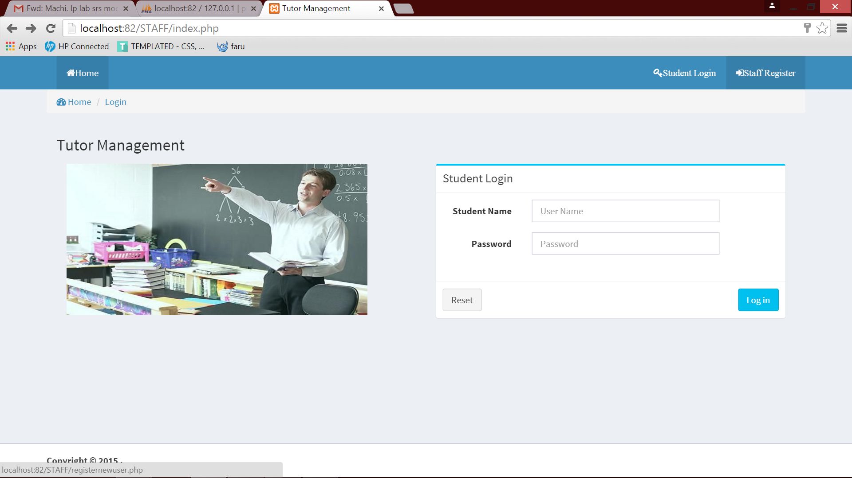

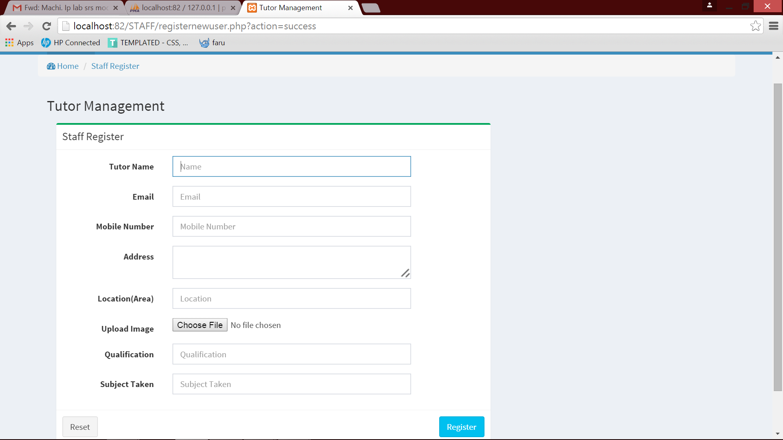
System Feature 2
allows students to select staffs in their location : this feature allows the student to search the staff according to the location they reside .this function is by triggering a search bar.

screenshots :
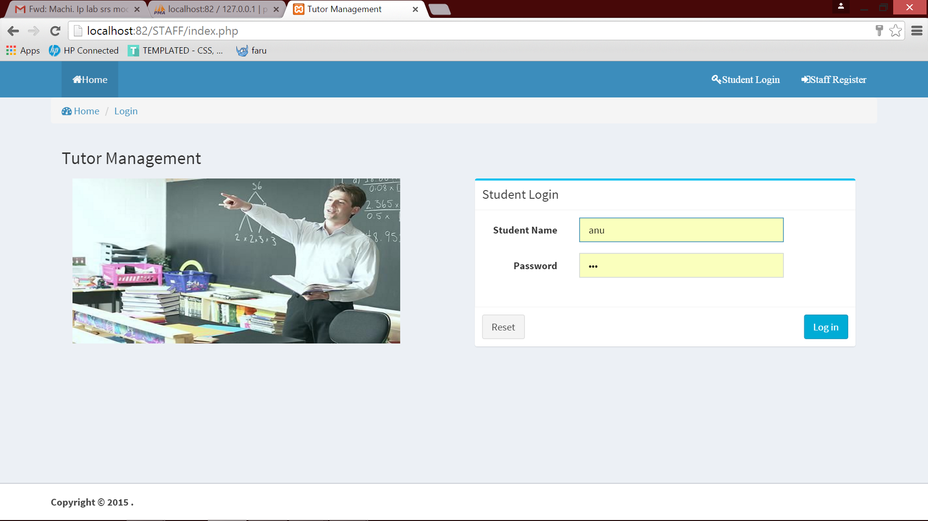

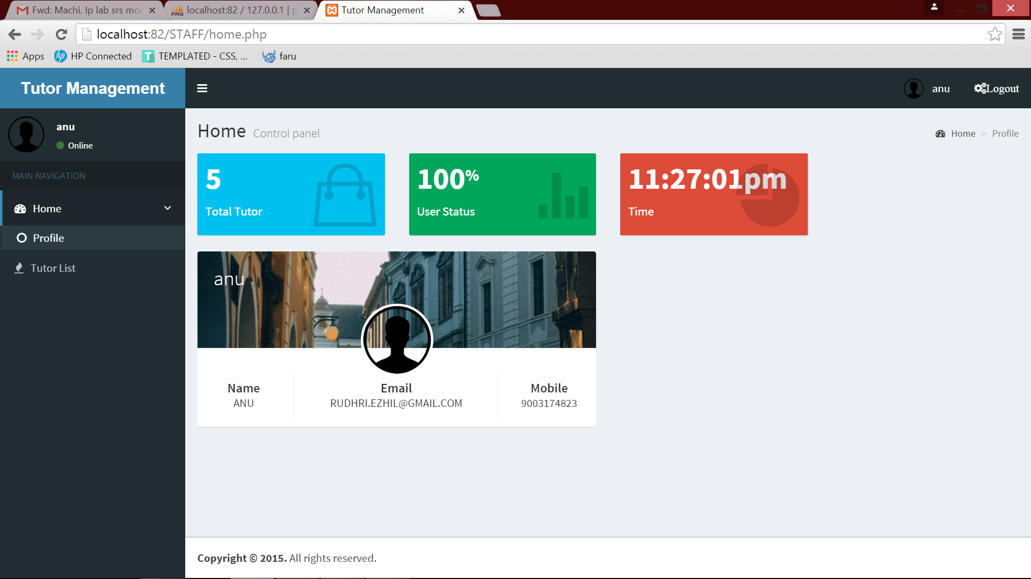
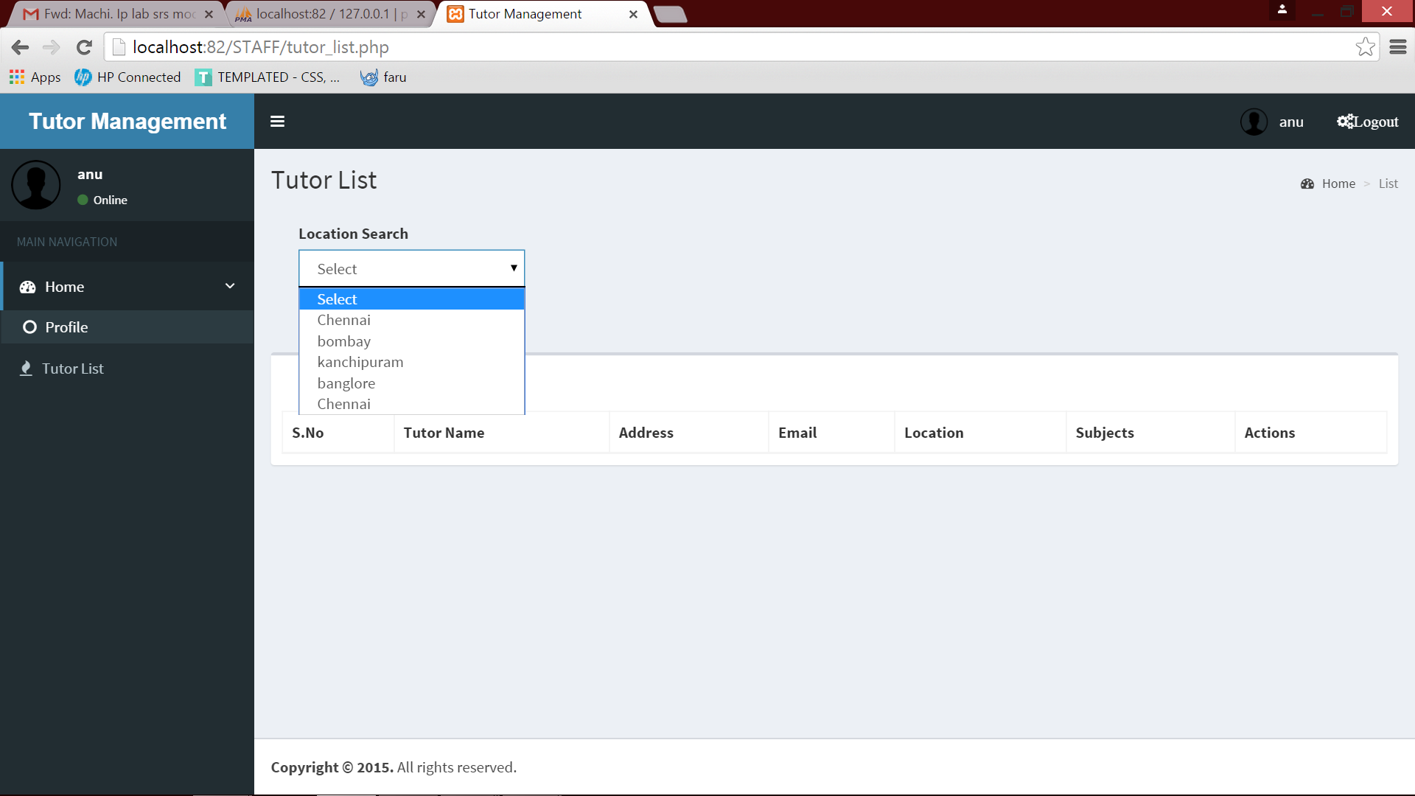

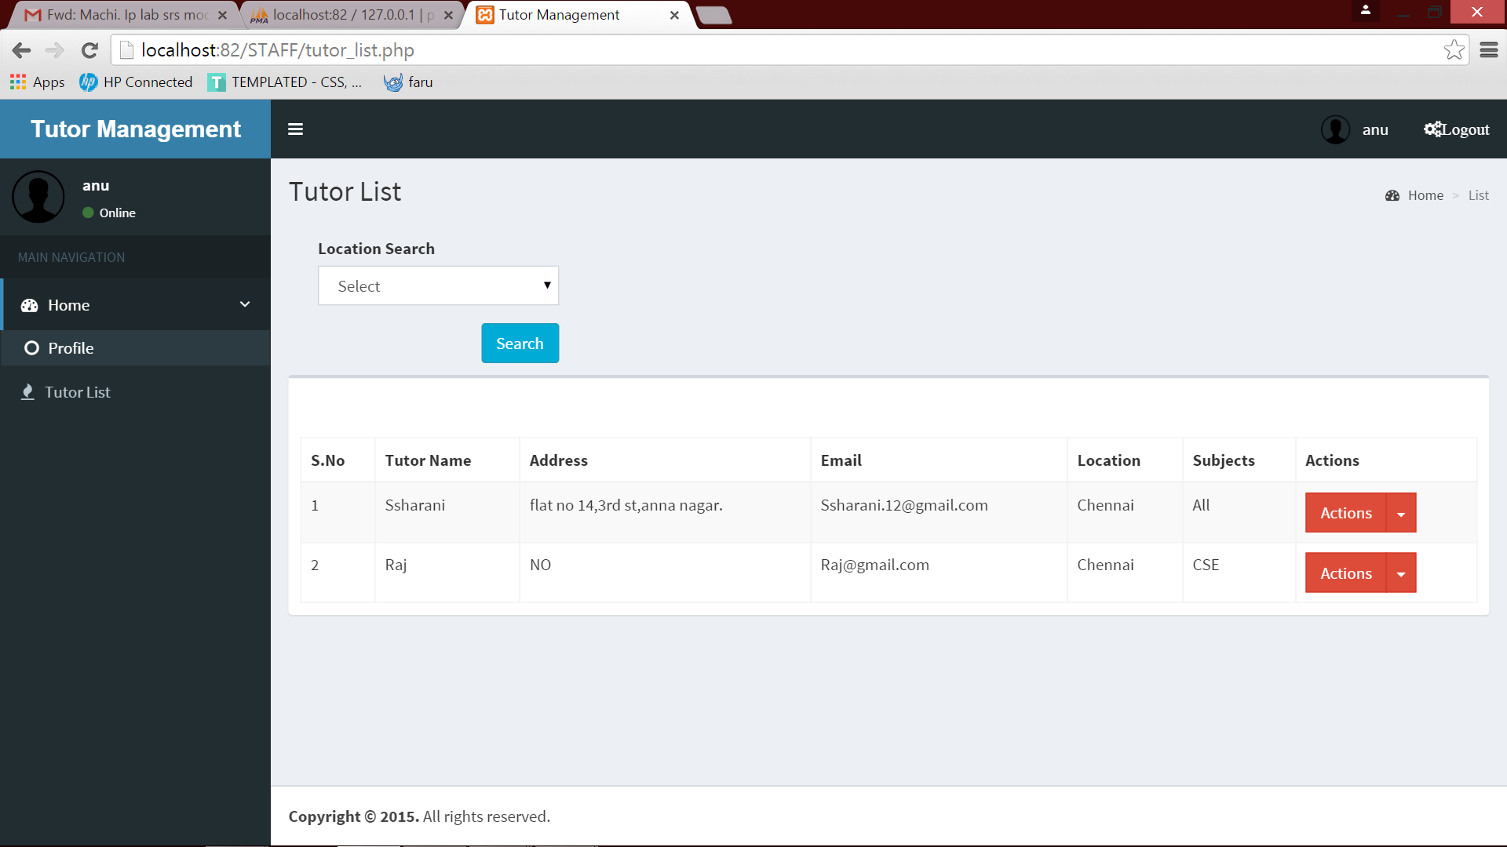
system feature 3:
student can send messages to the staffs they like: in case if the student likes the staff profile then he/she can select the staff by sending a notification or a message to the respective staff been slected .
screenshot :
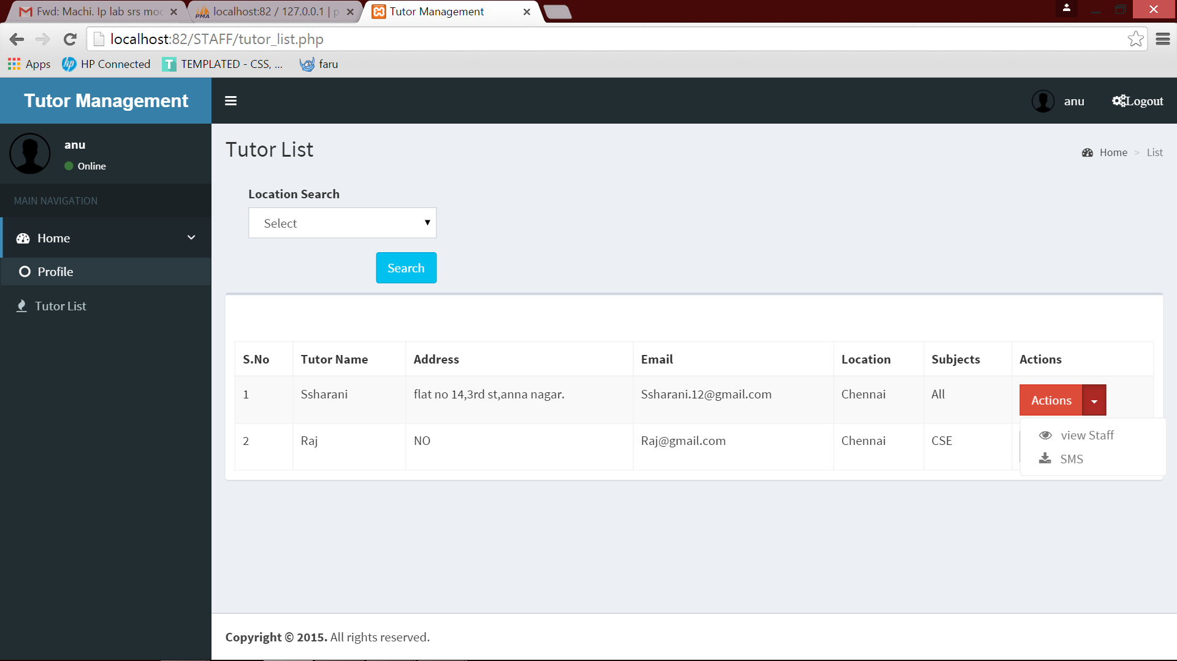

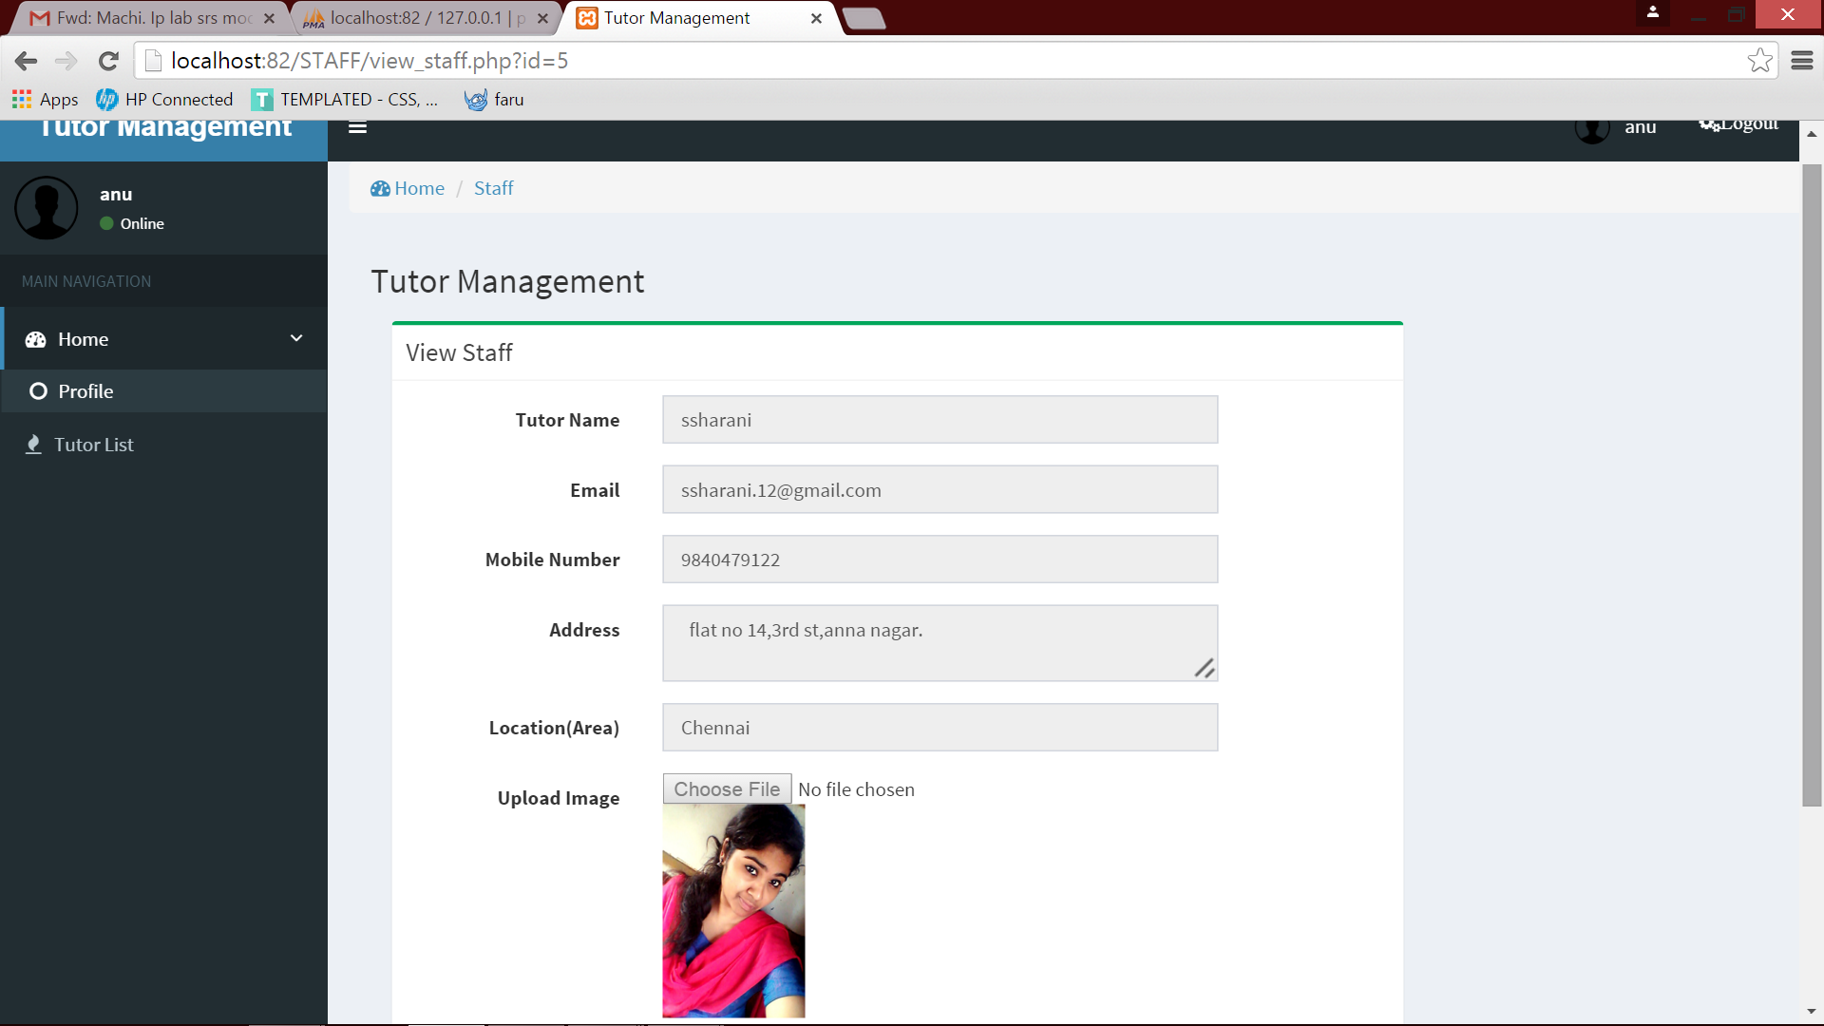

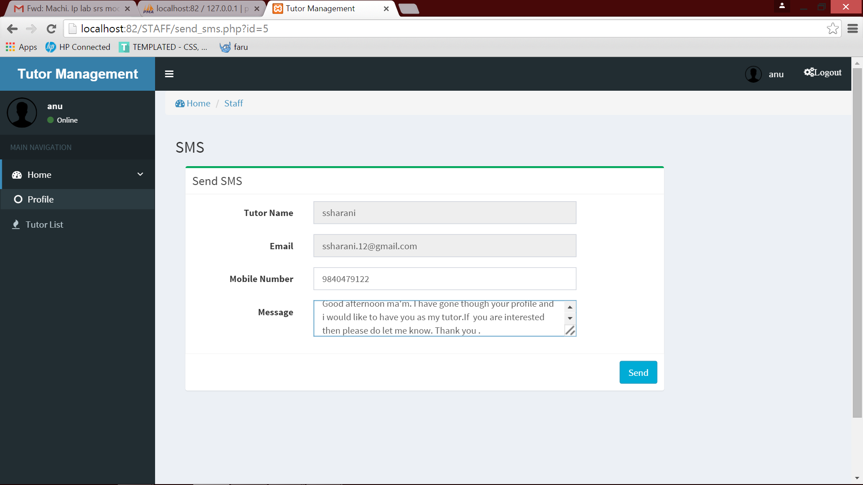

Coding:

home:

<!DOCTYPE html>
<html>
<?php
include "head_css_file.php";
?>

<body class="hold-transition skin-blue sidebar-mini">
<div class="wrapper">
<?php
include "includes/header.php";
?>
<?php
include "sidebar.php";
?>

<div class="content-wrapper">
<!-- Content Header (Page header) -->
<section class="content-header">
<h1>
Home
<small>Control panel</small>
</h1>
<ol class="breadcrumb">
<li><a href="#"><i class="fa fa-dashboard"></i> Home</a></li>
<li class="active">Profile</li>
</ol>
</section>
<?php $sql="select count(*) as `count` from register_new_user where new_delete=0";
// echo $sql; die;
$result = mysql_query($sql);
//echo count;
$data=mysql_fetch_assoc($result);
//echo $data['count'];
//print_r($result);
?>
<!-- Main content -->
<section class="content">
<!-- Small boxes (Stat box) -->

<div class="row">
<div class="col-lg-3 col-xs-6">
<!-- small box -->
<div class="small-box bg-aqua">
<div class="inner">
<h3><?php echo $data['count']; ?></h3>
<p>Total Tutor</p>
</div>
<div class="icon">
<i class="ion ion-bag"></i>
</div>
<!--
<a href="encrypted_files.php" class="small-box-footer">More info <i class="fa fa-arrow-circle-right"></i></a>
-->
</div>
</div><!-- ./col -->
<div class="col-lg-3 col-xs-6">
<!-- small box -->
<div class="small-box bg-green">
<div class="inner">
<h3>100<sup style="font-size: 20px">%</sup></h3>
<p>User Status</p>
</div>
<div class="icon">
<i class="ion ion-stats-bars"></i>
</div>
<!--
<a href="#" class="small-box-footer">More info <i class="fa fa-arrow-circle-right"></i></a>
-->
</div>
</div><!-- ./col -->

<div class="col-lg-3 col-xs-6">
<!-- small box -->
<div class="small-box bg-red">
<div class="inner">
<h3><?php
date_default_timezone_set("Asia/india");
echo date("h:i:sa");
?></h3>
<p>Time</p>
</div>
<div class="icon">
<i class="ion ion-pie-graph"></i>
</div>
<!--
<a href="#" class="small-box-footer">More info <i class="fa fa-arrow-circle-right"></i></a>
-->
</div>
</div><!-- ./col -->

<div class="col-md-6">
<!-- Widget: user widget style 1 -->
<div class="box box-widget widget-user">
<!-- Add the bg color to the header using any of the bg-* classes -->
<div style="background: url('dist/img/photo1.png') center center;" class="widget-user-header bg-black">
<h3 class="widget-user-username"><?php echo $_SESSION['SESS_NAME']; ?></h3>
<h5 class="widget-user-desc"></h5>
</div>
<div class="widget-user-image">
<img alt="User Avatar" src="images/user.png" class="img-circle">
</div>

<div class="box-footer">
<div class="row">
<div class="col-sm-3 border-right">
<div class="description-block">
<h5 class="description-header">Name</h5>
<span class="description-text"><?php echo $_SESSION['SESS_NAME']; ?></span>
</div><!-- /.description-block -->
</div><!-- /.col -->
<div class="col-sm-6 border-right">
<div class="description-block">
<h5 class="description-header">Email</h5>
<span class="description-text"><?php echo $_SESSION['SESS_EMAIL']; ?></span>
</div><!-- /.description-block -->
</div><!-- /.col -->
<div class="col-sm-3">
<div class="description-block">
<h5 class="description-header">Mobile</h5>
<span class="description-text"><?php echo $_SESSION['SESS_MOBILE']; ?></span>
</div><!-- /.description-block -->
</div><!-- /.col -->
</div><!-- /.row -->
</div>
</div><!-- /.widget-user -->
</div>

</div><!-- /.row -->

</section><!-- /.content -->

</div><!-- /.content-wrapper -->
<?php
include "includes/footer.php";
?>
<?php
include "footer_js_file.php";
?>
</body>
</html>

index:

<!DOCTYPE html>
<html>
<head>
<meta charset="utf-8">
<meta http-equiv="X-UA-Compatible" content="IE=edge">
<title>Tutor Management</title>
<!-- Tell the browser to be responsive to screen width -->
<meta content="width=device-width, initial-scale=1, maximum-scale=1, user-scalable=no" name="viewport">
<!-- Bootstrap 3.3.5 -->
<link rel="stylesheet" href="bootstrap/css/bootstrap.min.css">
<!-- Font Awesome -->
<link rel="stylesheet" href="https://maxcdn.bootstrapcdn.com/font-awesome/4.4.0/css/font-awesome.min.css">
<!-- Ionicons -->
<link rel="stylesheet" href="https://code.ionicframework.com/ionicons/2.0.1/css/ionicons.min.css">
<!-- Theme style -->
<link rel="stylesheet" href="dist/css/AdminLTE.min.css">

<link rel="stylesheet" href="dist/css/skins/_all-skins.min.css">

</head>
<!-- ADD THE CLASS layout-top-nav TO REMOVE THE SIDEBAR. -->
<body class="hold-transition skin-blue layout-top-nav">
<div class="wrapper">

<header class="main-header">
<nav class="navbar navbar-static-top">
<div class="container">
<div class="navbar-header">
<a href="#" class="navbar-brand"><b></b></a>
<button type="button" class="navbar-toggle collapsed" data-toggle="collapse" data-target="#navbar-collapse">
<i class="fa fa-bars"></i>
</button>
</div>

<!-- Collect the nav links, forms, and other content for toggling -->
<div class="collapse navbar-collapse pull-left" id="navbar-collapse">
<ul class="nav navbar-nav">
<li class="active"><a href="index.php"><i class="fa fa-home"></i>Home <span class="sr-only"></span></a> </li>

<li></li>
</ul>

</div><!-- /.navbar-collapse -->
<!-- Navbar Right Menu -->
<div class="navbar-custom-menu">
<ul class="nav navbar-nav">
<li><a href="index.php"><i class="fa fa-key">Student Login</i></a></li>

<li><a href="registernewuser.php"><i class="fa fa-sign-in">Staff Register</i></a></li>
</ul>
</div>
</div><!-- /.container-fluid -->
</nav>
</header>
<!-- Full Width Column -->
<div class="content-wrapper">
<div class="container">

<ol class="breadcrumb">
<li><a href="index.php"><i class="fa fa-dashboard"></i> Home</a></li>
<li><a href="#">Login</a></li>

</ol>
<!-- Content Header (Page header) -->
<section class="content-header">
<h1>Tutor Management</h1>

</section>
<?php
if($_REQUEST['action']=='error') { ?>
<div class="alert alert-danger" style="text-align:center;">

<strong><?php echo "Username and password not match."; ?></strong>
</div>
<?php
}
?>
<!-- Main content -->
<section class="content">
<div class="col-md-6">

<img src="images/tutor.jpg" alt="Mountain View" style="width:452px;height:228px;">
</div>
<div class="col-md-6">
<!-- Horizontal Form -->
<div class="box box-info">
<div class="box-header with-border">
<h3 class="box-title">Student Login</h3>
</div><!-- /.box-header -->
<!-- form start -->
<form class="form-horizontal" method="post" action="add.php?action=login">
<div class="box-body">
<div class="form-group">
<label for="inputEmail3" class="col-sm-3 control-label">Student Name</label>
<div class="col-sm-7">
<input type="text" class="form-control" id="name" name="name" required placeholder="User Name">
</div>
</div>
<div class="form-group">
<label for="inputPassword3" class="col-sm-3 control-label">Password</label>
<div class="col-sm-7">
<input type="password" class="form-control" id="" name="password" required placeholder="Password">
</div>
</div>
<div class="form-group">

</div>
</div><!-- /.box-body -->
<div class="box-footer">
<button type="reset" class="btn btn-default">Reset</button>
<button type="submit" class="btn btn-info pull-right">Log in</button>
</div><!-- /.box-footer -->
</form>
</div><!-- /.box -->

</div>
</section><!-- /.content -->
</div><!-- /.container -->
</div><!-- /.content-wrapper -->
<footer class="main-footer">
<div class="container">
<div class="pull-right hidden-xs">
<b></b>
</div>
<strong>Copyright &copy; 2015 <a href="#"></a>.</strong>
</div><!-- /.container -->
</footer>
</div><!-- ./wrapper -->
<!-- jQuery 2.1.4 -->
<script src="plugins/jQuery/jQuery-2.1.4.min.js"></script>
<!-- Bootstrap 3.3.5 -->
<script src="bootstrap/js/bootstrap.min.js"></script>
<!-- SlimScroll -->
<script src="plugins/slimScroll/jquery.slimscroll.min.js"></script>
<!-- FastClick -->
<script src="plugins/fastclick/fastclick.min.js"></script>
<!-- AdminLTE App -->
<script src="dist/js/app.min.js"></script>
<!-- AdminLTE for demo purposes -->
<script src="dist/js/demo.js"></script>
</body>
</html>
<script type="text/javascript">

$('.alert').fadeOut('slow');
</script>
Audit:

<!DOCTYPE html>
<html>
<?php
include "head_css_file.php";
?>

<body class="hold-transition skin-blue sidebar-mini">
<div class="wrapper">
<?php
include "includes/auditor_header.php";
?>
<?php
include "auditor_sidebar.php";
?>

<div class="content-wrapper">
<!-- Content Header (Page header) -->
<section class="content-header">
<h1>
Admin
<small>Control panel</small>
</h1>
<ol class="breadcrumb">
<li><a href="#"><i class="fa fa-dashboard"></i>Home</a></li>
<li class="active">Profile</li>
</ol>
</section>
<?php $sql="select count(*) as `count` from add_encrypted_files where encrypted_delete=0";
// echo $sql; die;
$result = mysql_query($sql);
//echo count;
$data=mysql_fetch_assoc($result);
//echo $data['count'];
//print_r($result);
?>
<!-- Main content -->
<section class="content">
<!-- Small boxes (Stat box) -->
<div class="row">

<div class="col-md-3 col-sm-6 col-xs-12">
<div class="info-box">
<span class="info-box-icon bg-red"><i class="fa fa-files-o"></i></span>
<div class="info-box-content">
<span class="info-box-text">Total Files</span>
<span class="info-box-number"><?php echo $data['count']; ?></span>
</div><!-- /.info-box-content -->
</div><!-- /.info-box -->
</div><!-- /.col -->

<?php $sql="select count(*) as `success` from add_encrypted_files where encrypted_delete=0 and encrypted_status=0";
// echo $sql; die;
$result = mysql_query($sql);

$data=mysql_fetch_assoc($result);

?>

<div class="col-md-3 col-sm-6 col-xs-12">
<div class="info-box">
<span class="info-box-icon bg-green"><i class="fa fa-flag-o"></i></span>
<div class="info-box-content">
<span class="info-box-text">Sucess Files</span>
<span class="info-box-number"><?php echo $data['success']; ?></span>
</div><!-- /.info-box-content -->
</div><!-- /.info-box -->
</div><!-- /.col -->

<?php $sql="select count(*) as `unsuccess` from add_encrypted_files where encrypted_delete=0 and encrypted_status=1";
// echo $sql; die;
$result = mysql_query($sql);

$data=mysql_fetch_assoc($result);

?>
<div class="col-md-3 col-sm-6 col-xs-12">
<div class="info-box">
<span class="info-box-icon bg-yellow"><i class="fa fa-flag-o"></i></span>
<div class="info-box-content">
<span class="info-box-text">Pending Files</span>
<span class="info-box-number"><?php echo $data['unsuccess']; ?></span>
</div><!-- /.info-box-content -->
</div><!-- /.info-box -->
</div><!-- /.col -->

</div><!-- ./col -->
<div class="col-md-6">
<!-- Widget: user widget style 1 -->
<div class="box box-widget widget-user">
<!-- Add the bg color to the header using any of the bg-* classes -->
<div style="background: url('dist/img/photo1.png') center center;" class="widget-user-header bg-black">
<h3 class="widget-user-username">Auditor</h3>
<h5 class="widget-user-desc"></h5>
</div>
<div class="widget-user-image">
<img alt="User Avatar" src="images/user.png" class="img-circle">
</div>
<div class="box-footer">
<div class="row">
<div class="col-sm-4 border-right">
<div class="description-block">
<h5 class="description-header">Auditor</h5>
<span class="description-text"></span>
</div><!-- /.description-block -->
</div><!-- /.col -->
<div class="col-sm-4 border-right">
<div class="description-block">
<h5 class="description-header">Email</h5>
<span class="description-text">auditor@gmail.com</span>
</div><!-- /.description-block -->
</div><!-- /.col -->
<div class="col-sm-4">
<div class="description-block">
<h5 class="description-header">Status</h5>
<span class="description-text"><a href="#"><i class="fa fa-circle text-success"></i> Online</a></span>
</div><!-- /.description-block -->
</div><!-- /.col -->
</div><!-- /.row -->
</div>
</div><!-- /.widget-user -->
</div>
</div><!-- /.row -->
</section><!-- /.content -->
</div><!-- /.content-wrapper -->

<?php
include "includes/footer.php";
?>
<?php
include "footer_js_file.php";
?>
</body>
</html>

sms code:

<?php
ob_start();
session_start();
require "includes/config.php";
//error_reporting(0);
$errmsg_arr = array();
$errflag = false;
$action=$_GET['action'];
//----------------------------New User-------------------------------//
if($action == "add_new_user")
{
$name = $_POST['name'];
$email = $_POST['email'];
$mobile_number = $_POST['mobile_number'];
$address =$_POST['address'];
$upload =$_POST['filess'];

if (isset($_FILES['filess']['name']))
{
$upload = $_FILES['filess']['name'];

$strFilePath="upload/";
$logo = $_FILES['filess']['name'];

$tmp_name = $_FILES['filess']['tmp_name'];

$target_path = $strFilePath . basename( $_FILES['filess']['name']);
copy($tmp_name, $target_path);

}
else
{
$upload = '';
}

$location =$_POST['location'];
$qulai =$_POST['Qualification'];
$subject =$_POST['subject'];

$insert = "INSERT INTO `register_new_user`(`new_name`,`new_email`,`new_mobile_number`,`new_address`,`new_location`,`new_image`,`new_quali`,`new_subject`) VALUES ('$name','$email','$mobile_number','$address','$location','$upload','$qulai','$subject')";
//echo $insert; exit();

$in = mysql_query($insert);
if($in)
{
header("location:registernewuser.php?action=success");
}
else
{
header("location: registernewuser.php?action=error");
}
}

//----------------------------login-------------------------------//
if($action == "login")
{
$username = $_POST['name'];
$password = $_POST['password'];

//Input Validations
if($username == '') {
//echo 'empty';exit;
$errmsg_arr[] = 'Username missing';
$errflag = true;
}
if($password == '') {
$errmsg_arr[] = 'Password missing';
$errflag = true;
}
$sql = "select * from student_login where st_name='".$username."' and st_password='".$password."'" ;
//echo $sql; die();
$result = mysql_query($sql);
$count = mysql_num_rows($result);
//Check whether the query was successful or not
if($count > 0) {
$row = mysql_fetch_array($result);
$_SESSION['SESS_ID'] = $row['st_id'];
$_SESSION['SESS_NAME'] = $row['st_name'];
$_SESSION['SESS_MOBILE'] = $row['st_mobile_number'];
$_SESSION['SESS_EMAIL'] = $row['st_email'];
header("location: home.php");
}

else {
//Login failed
$errmsg_arr[] = 'Username and password not match.';
$errflag = true;
if($errflag) {
$_SESSION['ERRMSG_ARR'] = $errmsg_arr;
session_write_close();
header("location: index.php?action=error");
exit();
}
} }
if($action == "send_sms")
{
//echo "khgkjgkk";
//$username = $_POST['name'];
$number = $_POST['mobile_number'];
$msg = $_POST['msg'];
/****************************************************************************************/
$str = trim(str_replace(' ','%20', $msg));
$url="http://cloud.smsindiahub.in/vendorsms/pushsms.aspx?user=anurudhri&password=evesunsetanu&msisdn=".$number."&sid=WEBSMS&msg=".$str."&fl=0";
// create a new cURL resource
$ch = curl_init();
// set URL and other appropriate options
curl_setopt($ch, CURLOPT_URL,$url);
// grab URL and pass it to the browser
curl_exec($ch);
// close cURL resource, and free up system resources
curl_close($ch);
//*******************************************************************************************************/
if($ch)
{
header("location:home.php?action=success");
}
else
{
header("location:home.php?action=success");
}
}?>

Conclusion :

This is the tutor management application and its working . Thus the study and implementation of Tutor Management System has been done and verified successfully.Hence, these are the most unique system features coded and implemented successfully.

